Regression:

1.1

The data set im using consists of many attributes the ones im using are engine size, price and make.

1.2

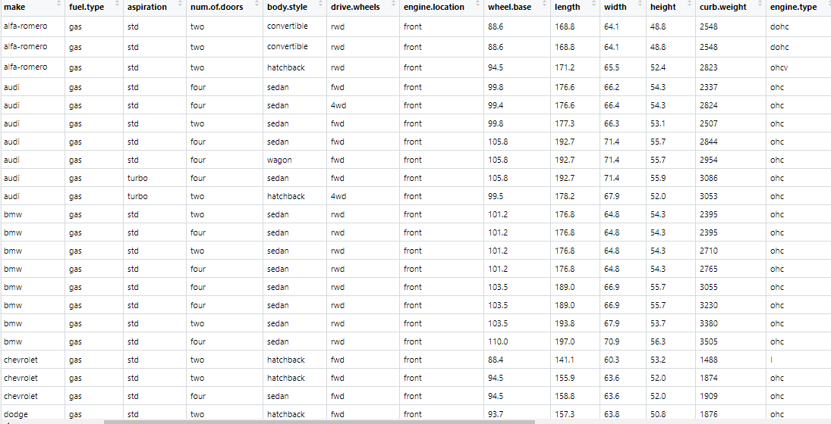

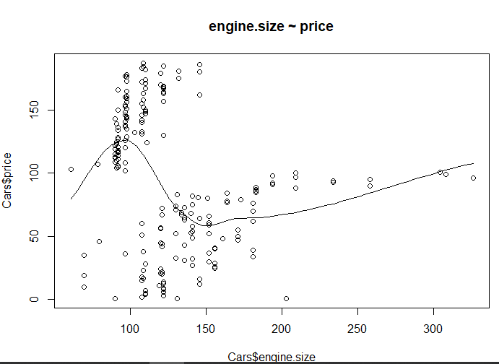

1.3



1.4

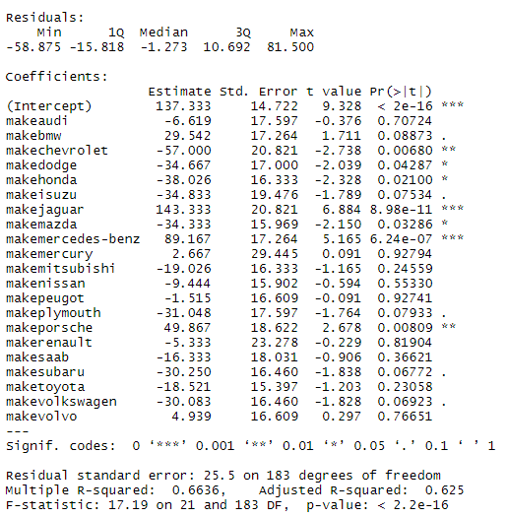

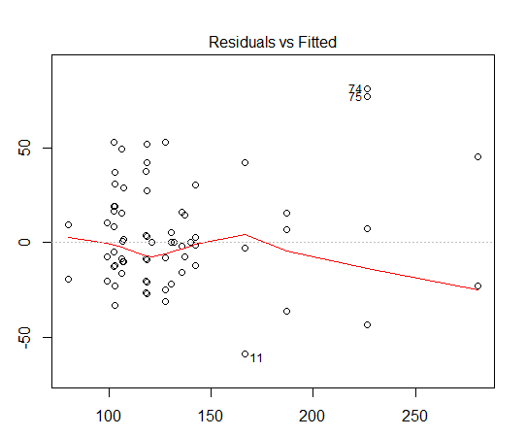

1.5

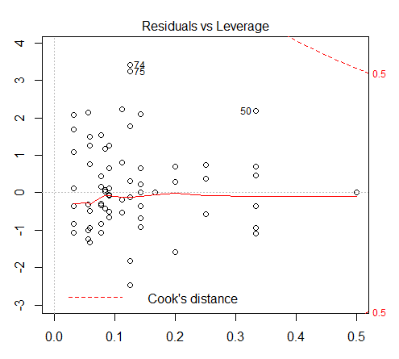

1.6

Decision Trees:

2.1

The data set im using is Absenteeism.

2.2

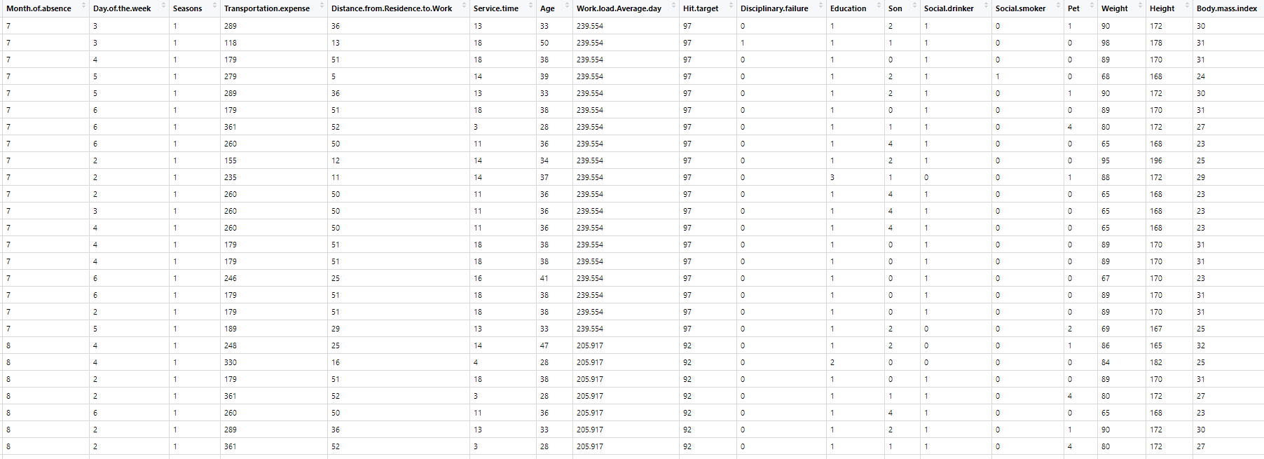

2.3

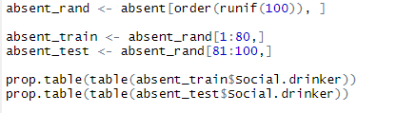

2.4

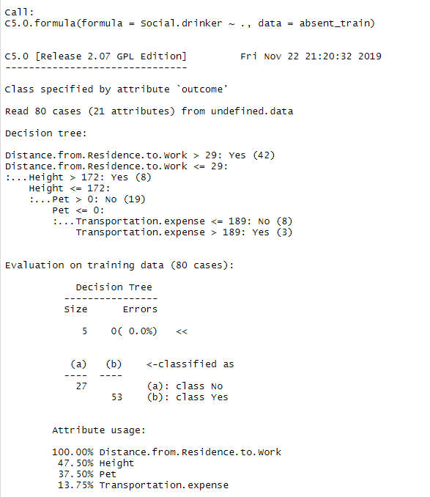

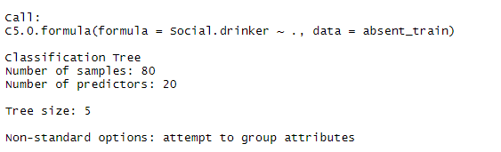

2.5

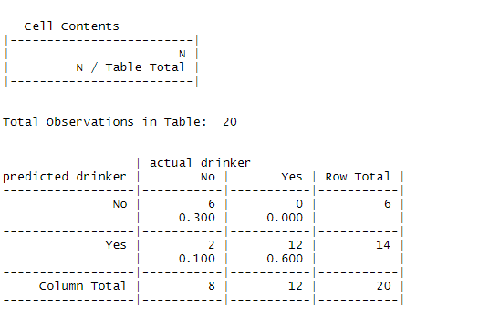

2.6

Over all 90% of predictions mathed the actual outcomes what is quite good result.

KNN:

3.1

3.2



3.3

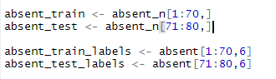

3.4

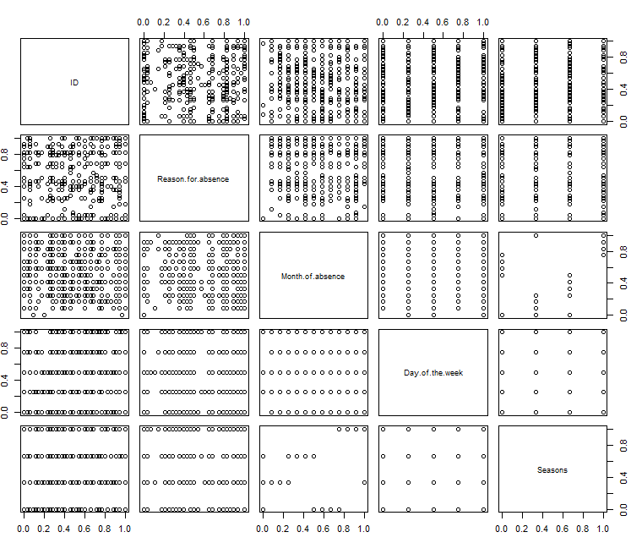

3.5

